Lab 2: UDTs, UDFs, and Leaflet

Christen Ford

Part One Output:

Results from running test script 1:

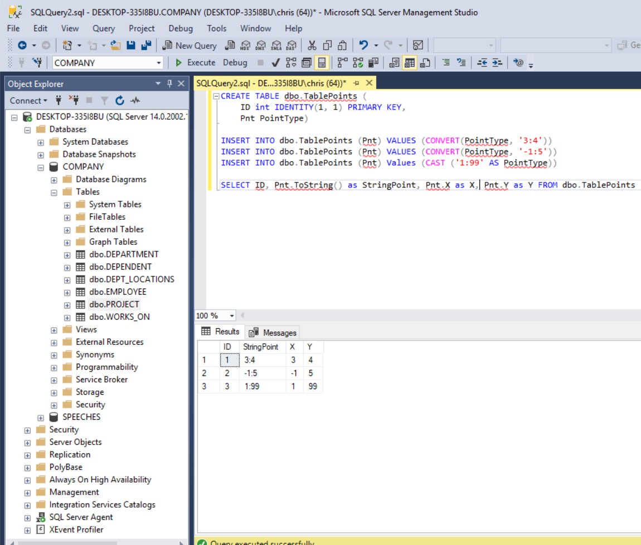

Results from running test script 2:

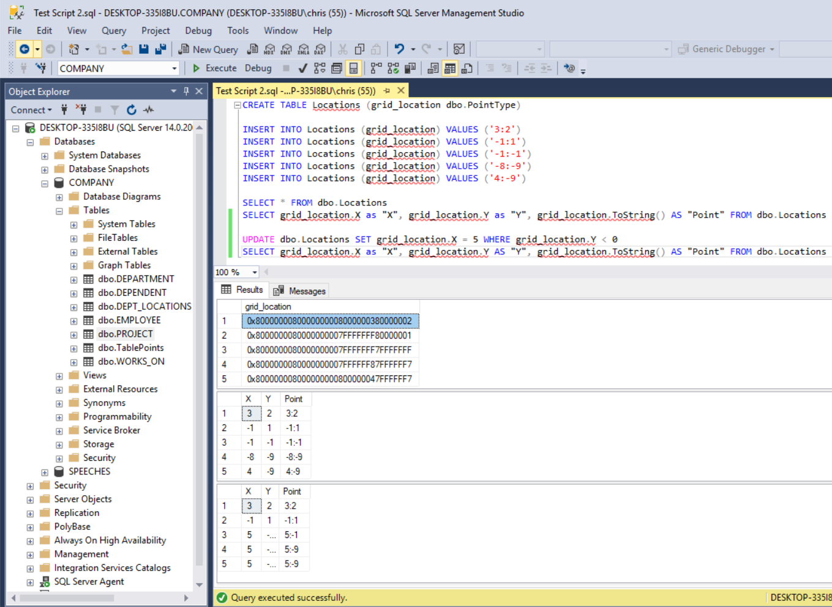

Part Two Output:

Note that the output produced by my function removes stop words from the original text and stems the remaining words down to their root words. This is why the words look strange in the index.

Example of importing the assembly into the database and creating the table valued function:

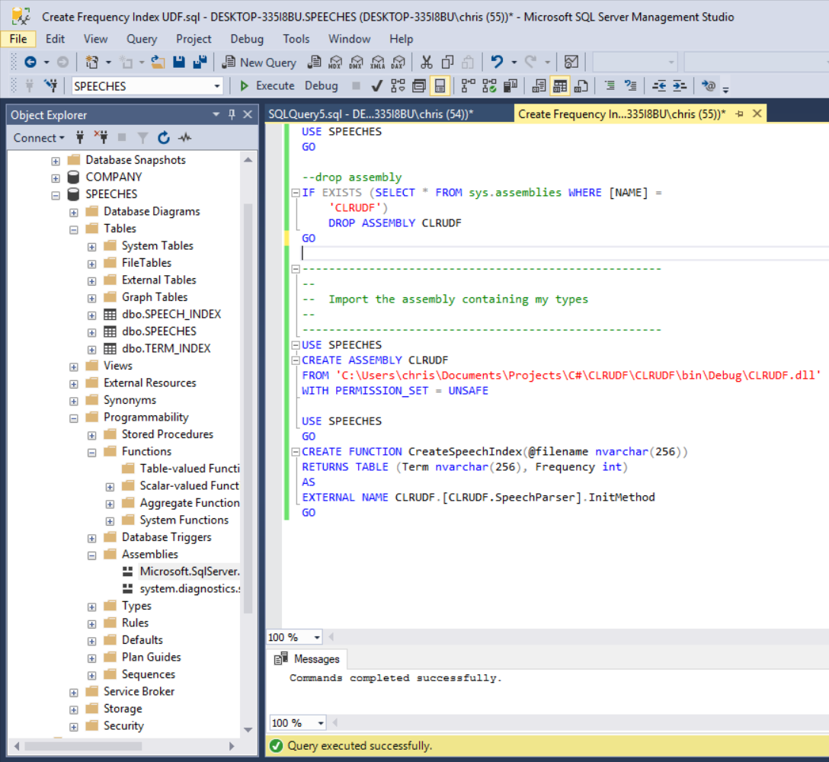

Inserting values into the inverted index table in the database using the table value function as a data source:

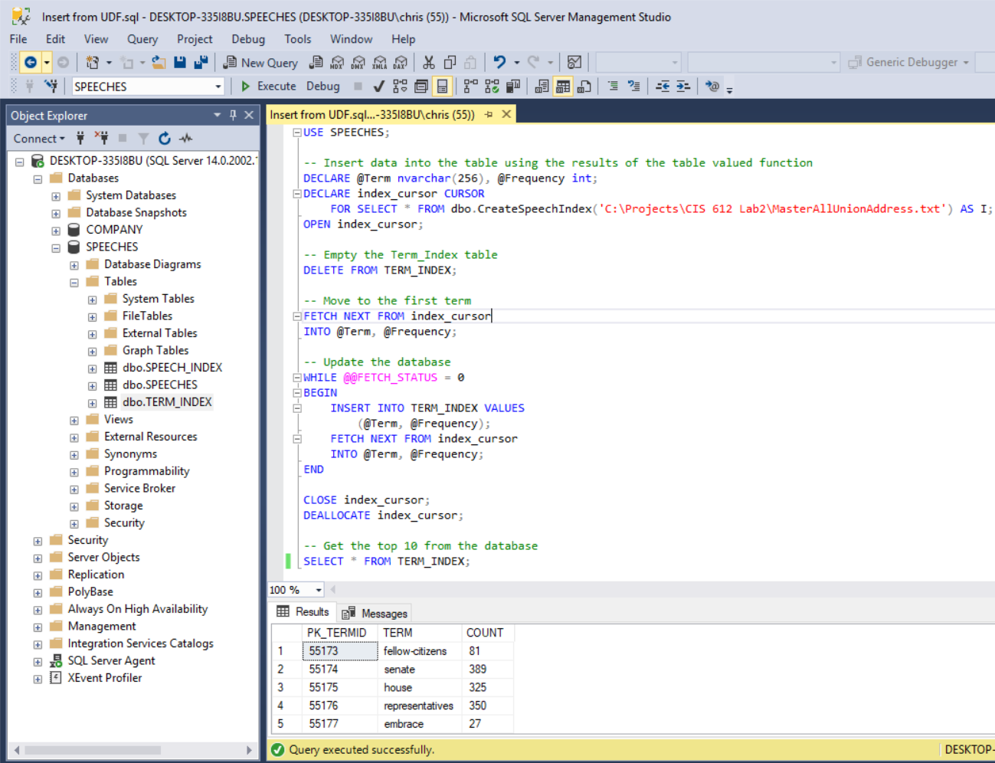

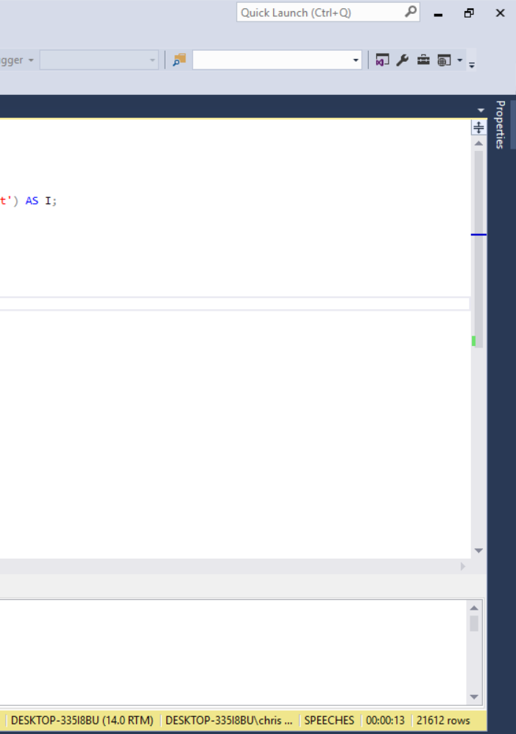

Output for Part 3:

